Кузнецов Антон   
ИВТ 3 курс 1 группа

**A Vocabulary**

1.

1. b
2. a
3. g
4. e
5. d
6. h
7. f
8. 8

2.

1. c
2. d
3. a
4. g
5. b
6. e
7. f

3.

1. d
2. f
3. a
4. c
5. g
6. h
7. e
8. b

Картинки сильно смазались  
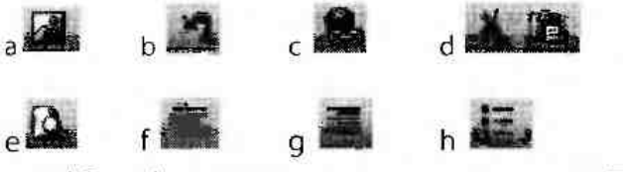

4.

1. column
2. row
3. cell
4. formula
5. field
6. record
7. query

**B Language work**

5.

1. I need advice on which computer to buy.
2. If any information is inaccurate, please let me know.
3. There are many versions of Windows
4. Sarah often uses a laptop to do homework.
5. I spent some time playing with the program.

6.

In our classroom, we have five computers connected to 1) the internet. We use them to prepare 2)- projects and reports, and to study subjects like 3) an music, Art and Science. This year, we are preparing 4) an exchange with students from a partner school in Europe. Our teachers use 5) a video projector to make 6) an presentations on a large screen. At home I have a desktop PC and 7) an inkjet printer. I use my computer to play games, send and receive 8) an email, and get 9) the information from 10) the Web.

7.

1. businesses
2. software
3. analyses
4. taxes
5. switches
6. women
7. children
8. formulas
9. queries

8.

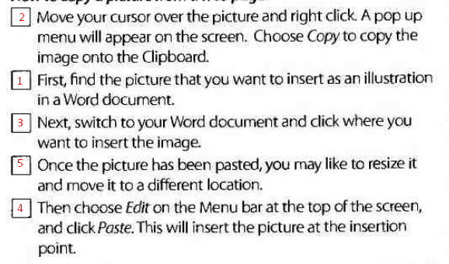

**C Reading**

9.

1. false
2. true
3. false
4. true

10.

1. word processor, spreadsheet program, presentation program etc